**What is sigmoid function?**

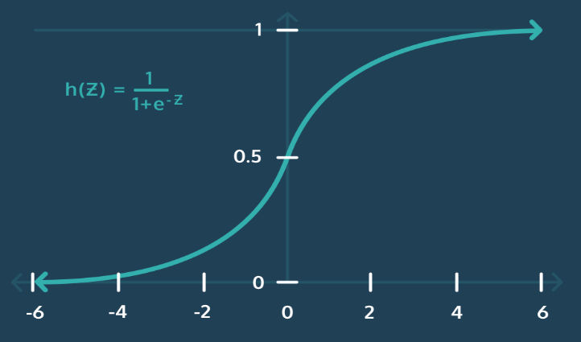Sigmoid function is a S-shaped curve that takes real valued number and map it into value in a range between 0 and 1.

**How it works?**

The sigmoid function is widely used in classification problems because its output can be interpreted as a probability.

We map the log-odds z (calculated by the multiplication of feature coefficients and feature values and add the intercept) to the range [0,1] to classify the probability of a class.

Where e to the power (-z) is the exponential function, which can be written in numpy as np.exp(-z).

def sigmoid(z):

denominator=1 + np.exp(-z)

return 1/denominator

NOTE:

As log-odds calculates the value and output the value in a range -∞ to +∞ , then sigmoid function comes into action and link the log-odds value to the value in range 0 and 1 for classification problems.

Therefore, this enables Logistic Regression algorithm to output the probability of a sample data belonging to the positive class or category.